Name: Garima Nagesh Joshi

Cloud Computing: Infrastructure as a service using AWS

Q1.) Implement windows machine using AWS EC2.

Ans:

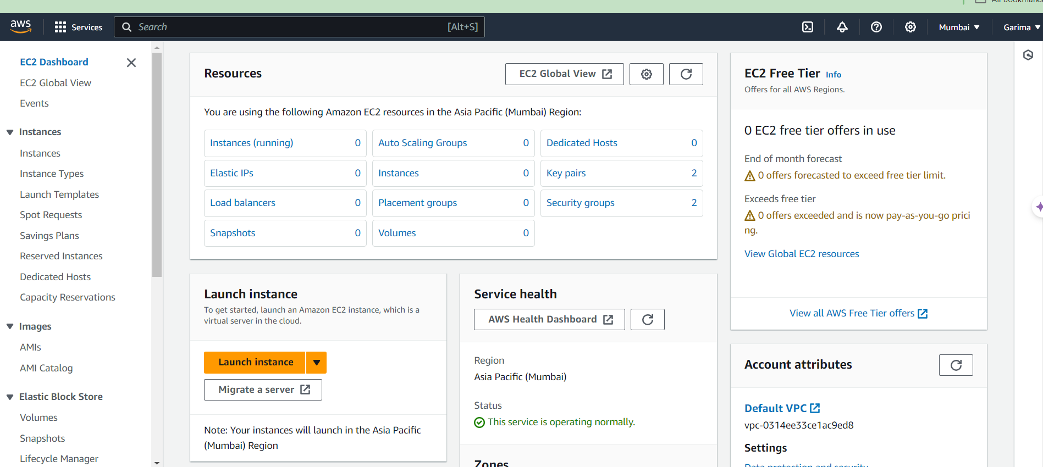

From resources section, select “Instances (Running)” option.

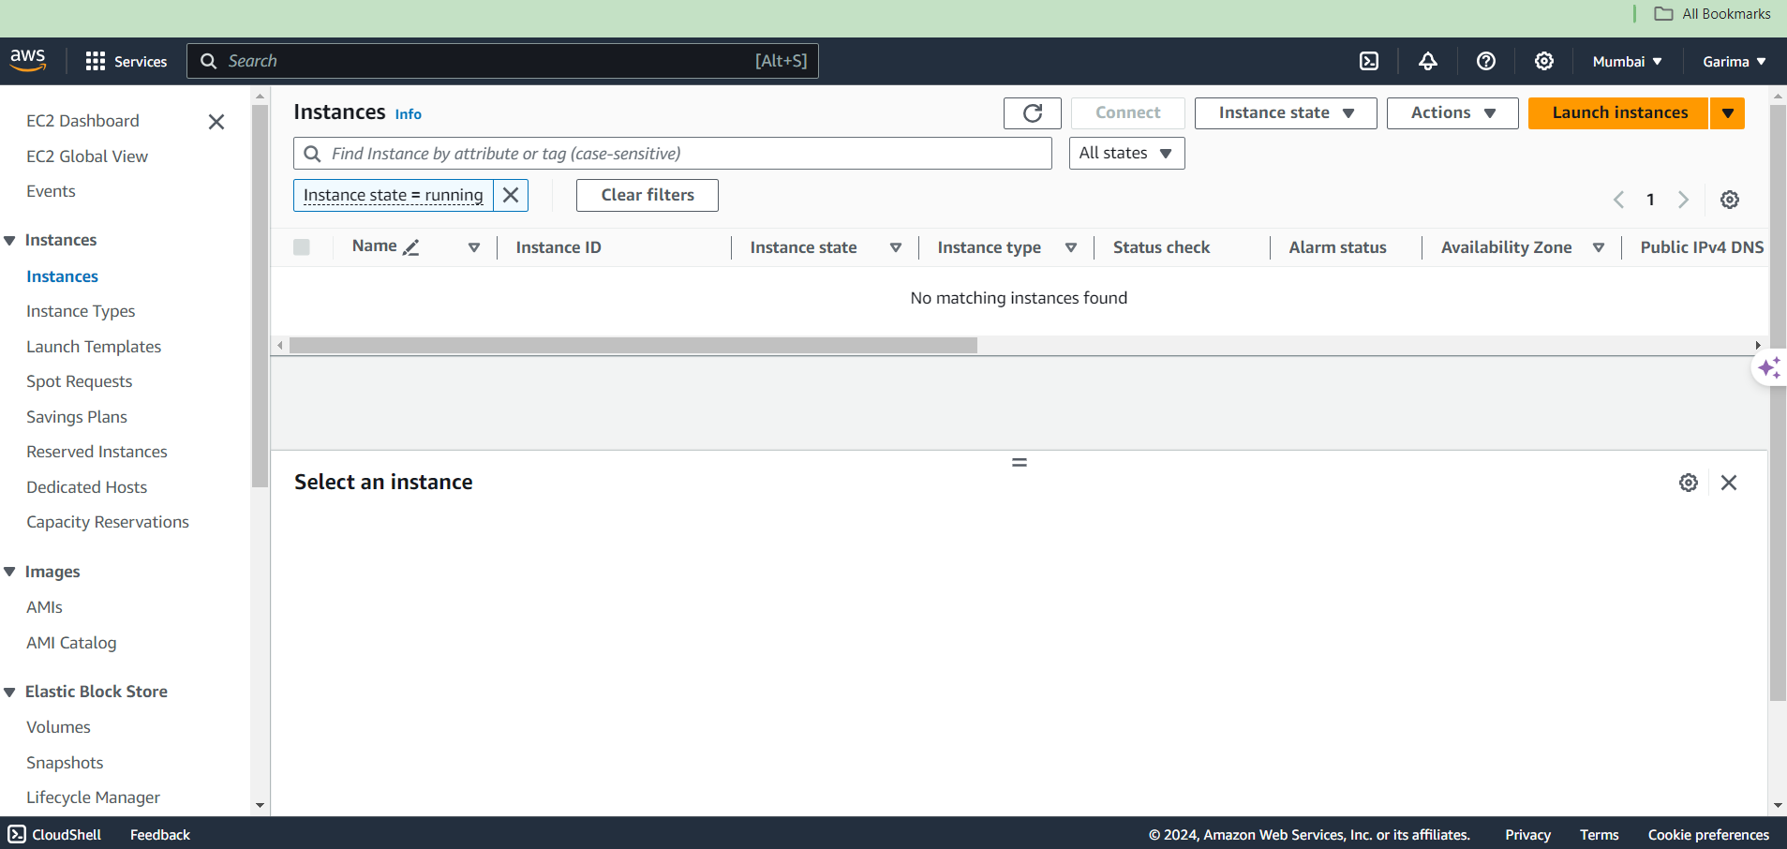

Currently there are no instances running. To launch an instance, click on the “Launch instances” button at the top right corner.

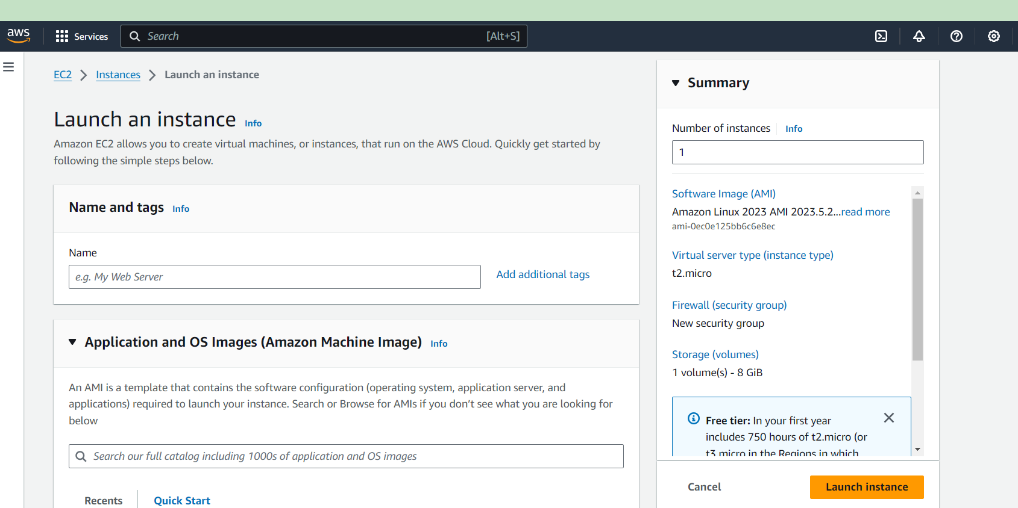

We are creating only one instance for windows. So, in “Summary”, the number of instances will be 1. In “Name and tags”, assign a name to the instance. Here we give the name “windows_server”.

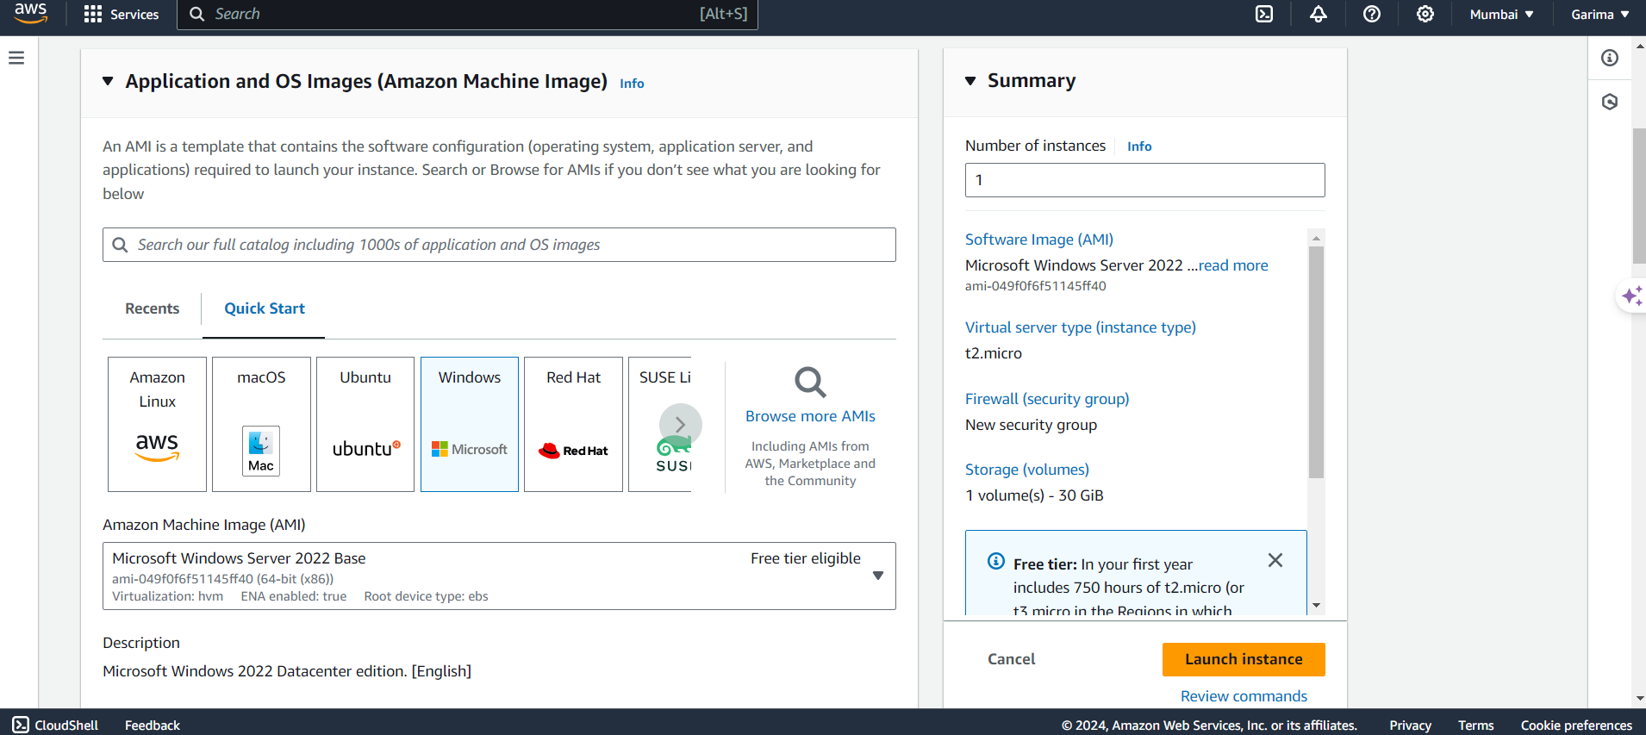

In “Application and OS Images (AMI)” section select the “Windows (Microsoft)” AMI. Select the AMI with the “Free Tier eligible” option only since the account is for free access purpose.

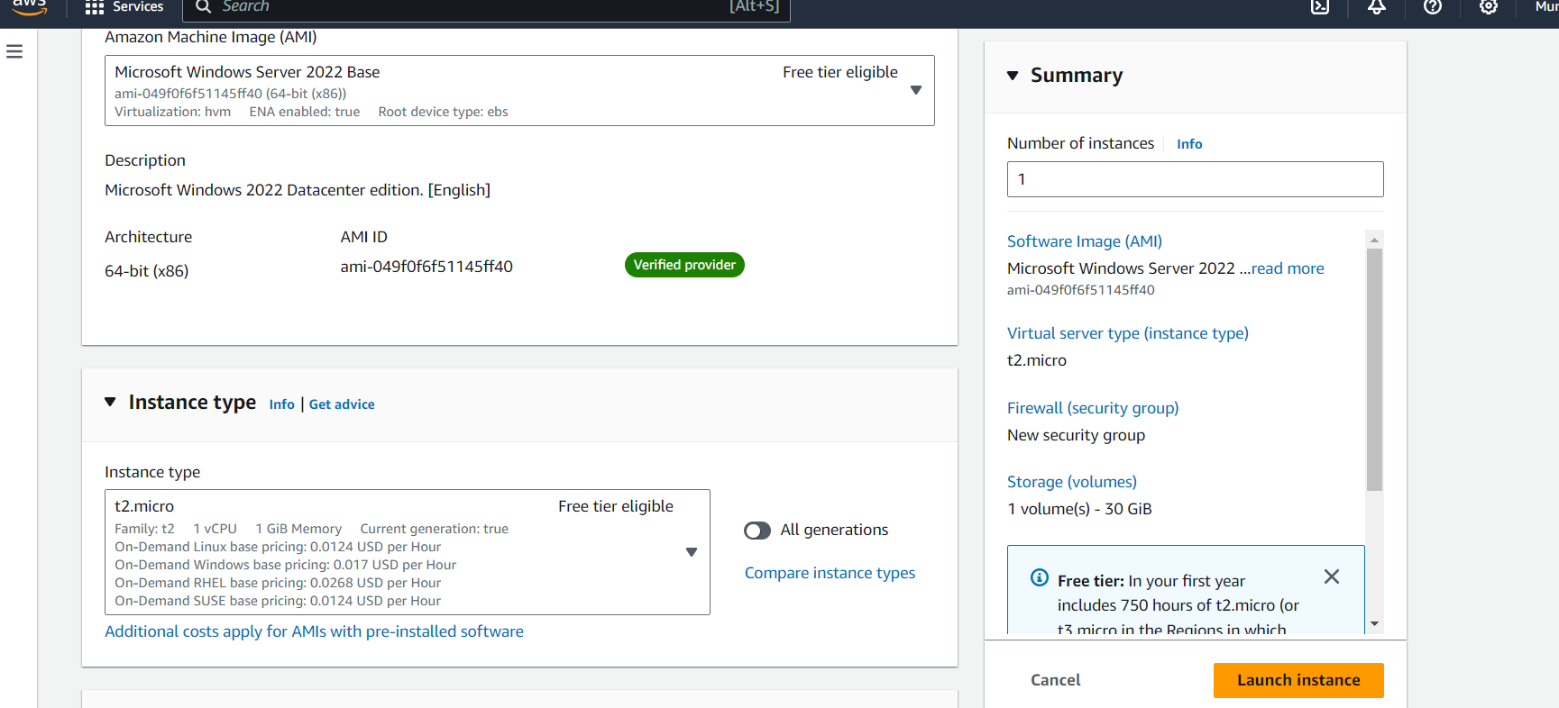

Instance types: We select our virtual CPUs and RAM/ memory associated. By default, the free tier eligible instance is selected. We select the latest “t2.micro” instance type.

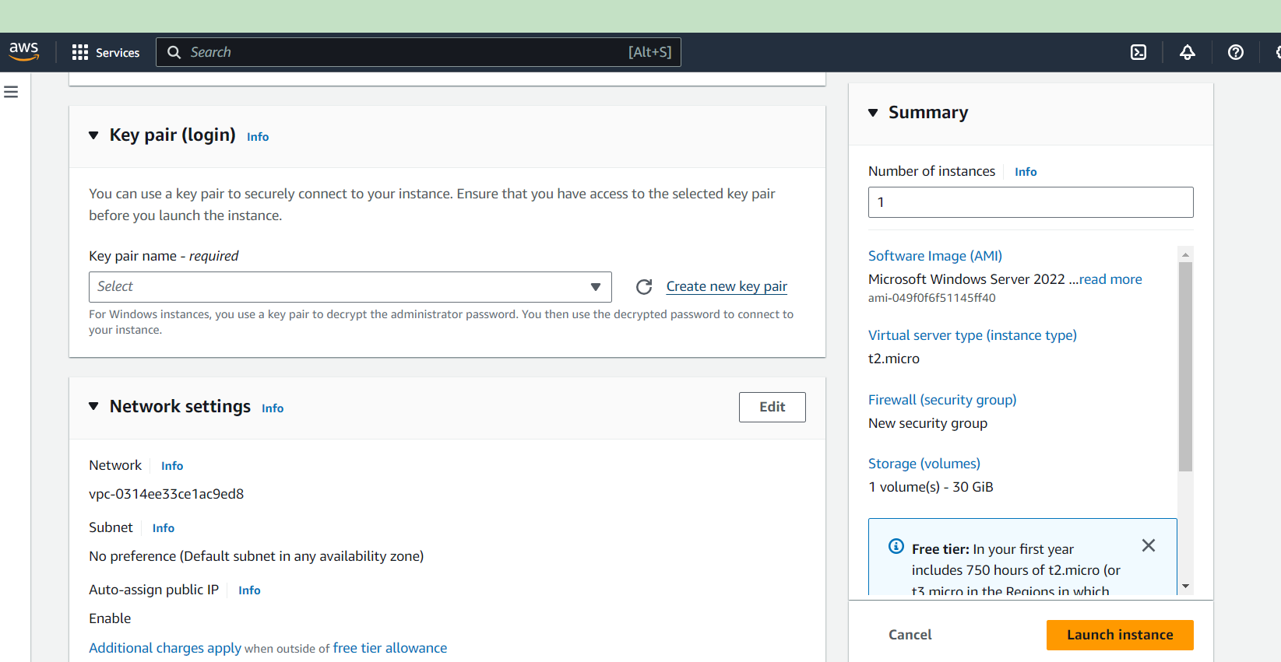

To login to the particular instance, we need keypair. Select the “Create new key pair” option at right of the drop-down box.

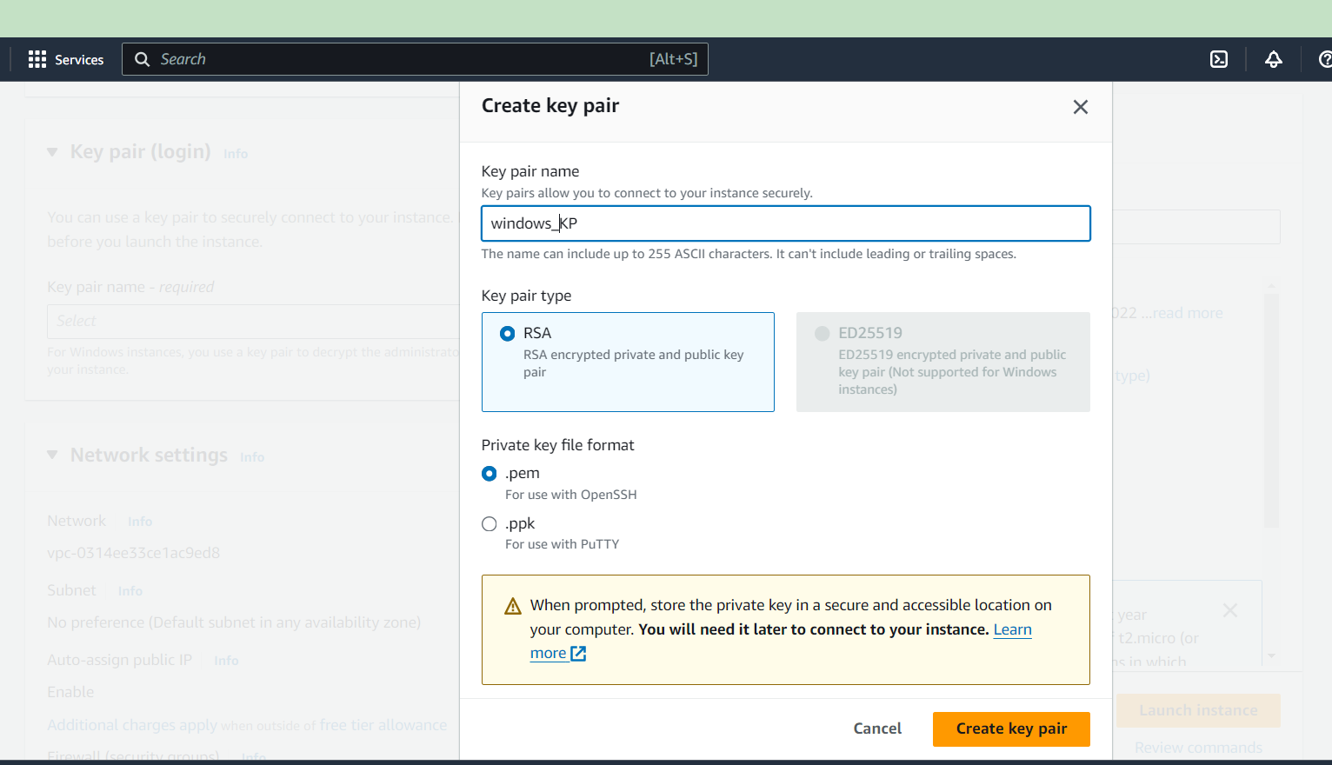

Assign name to key pair. Select “.pem” or “.ppk” key file format and create key pair. Accordingly, a file will be downloaded.

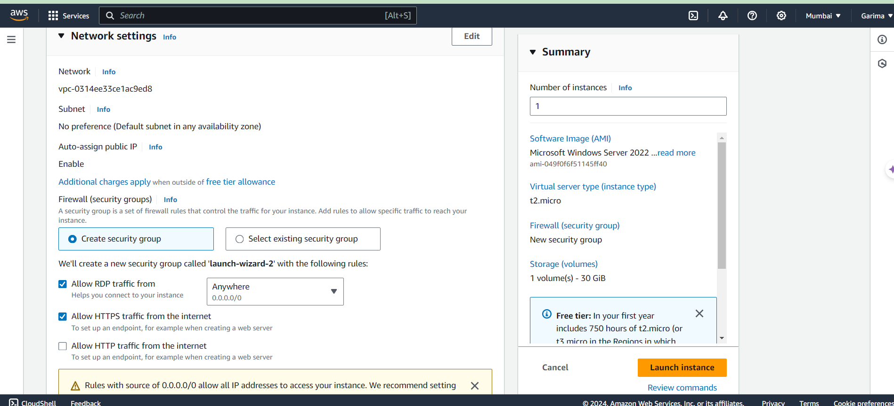

In “Network” settings, select “Create security group”. Select the 2 check boxes and then, at bottom right corner, select the “Launch” instance button to launch the instance.

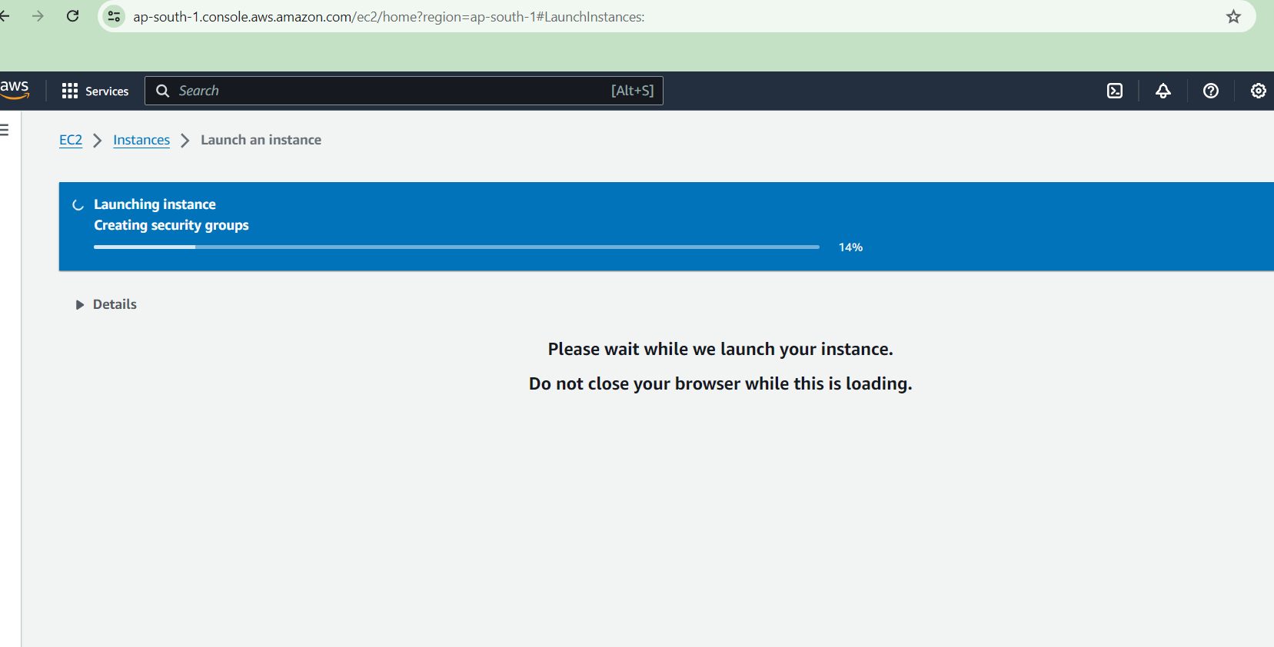

Once this completes. The instance will be launched.

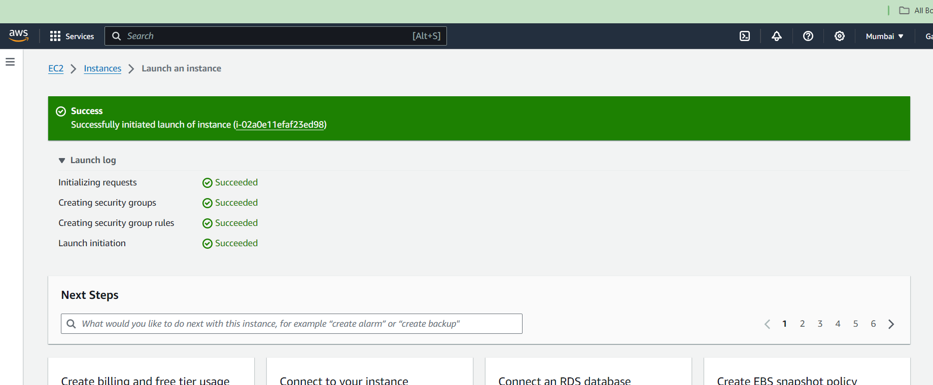

Once the instance in launched, this page should appear. Then at top left corner, above the green dialogue box, go on “Instances” option

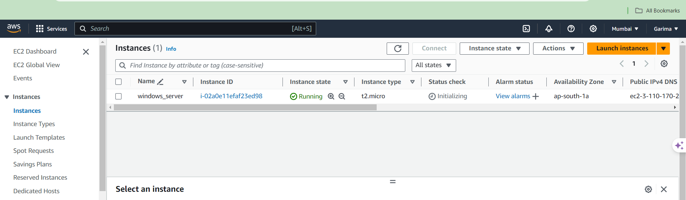

Here, we get to see the list of instances that we have launched. The instance state currently is “Running” indicating that the code is being processed. When it is processed and checking is done, the Status check column will show “2/2 passed”.

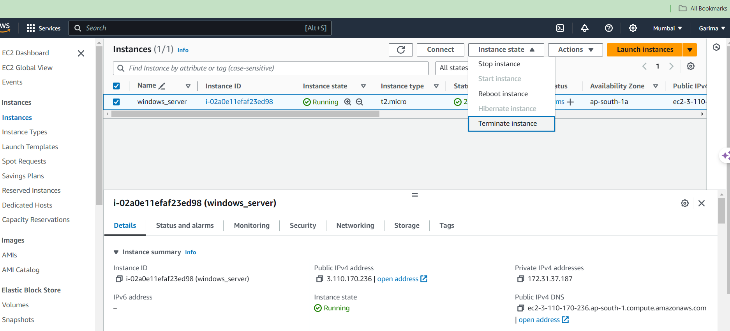

To terminate the instance, select that instance, go to “Instance state” drop down and select “Terminate instance” option.

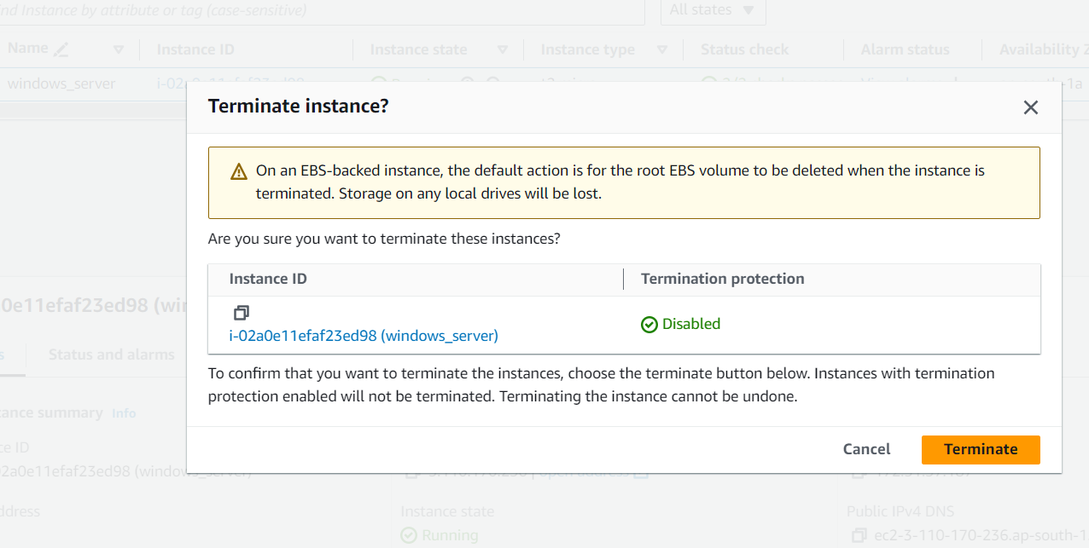

Click on “Terminate” button

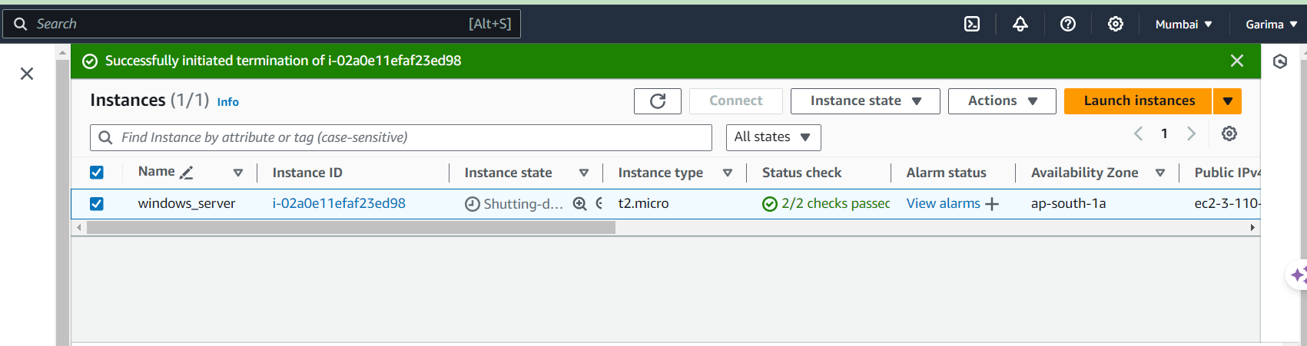

A dialogue box will appear stating termination of instance and the instance state will change to “Shutting-down”. When it is completely terminated, the state will change to “Terminated”.

Q2.) Implement Ubuntu machine using AWS ec2 and execute the Linux commands.

Ans:



From resources section, select “Instances (Running)” option.



Currently there are no instances running. To launch an instance, click on the “Launch instances” button at the top right corner.



We are creating only one instance for windows. So, in “Summary”, the number of instances will be 1. In “Name and tags”, assign a name to the instance. Here we give the name “ubuntu_server”.

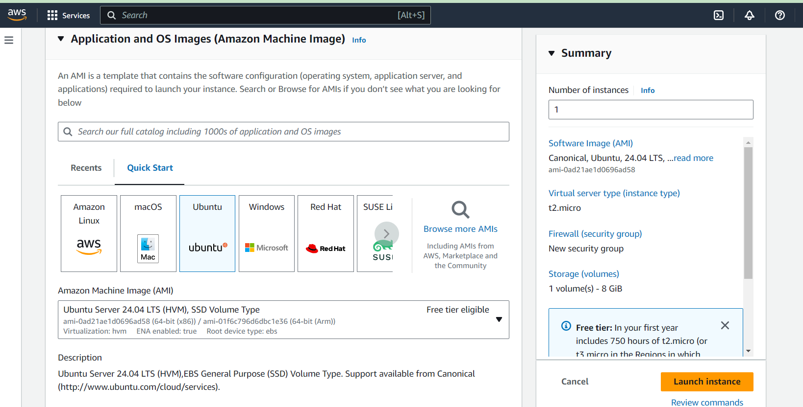

In “Application and OS Images (AMI)” section select the “Ubuntu” AMI. Select the latest AMI with the “Free Tier eligible” option only since the account is for free access purpose.

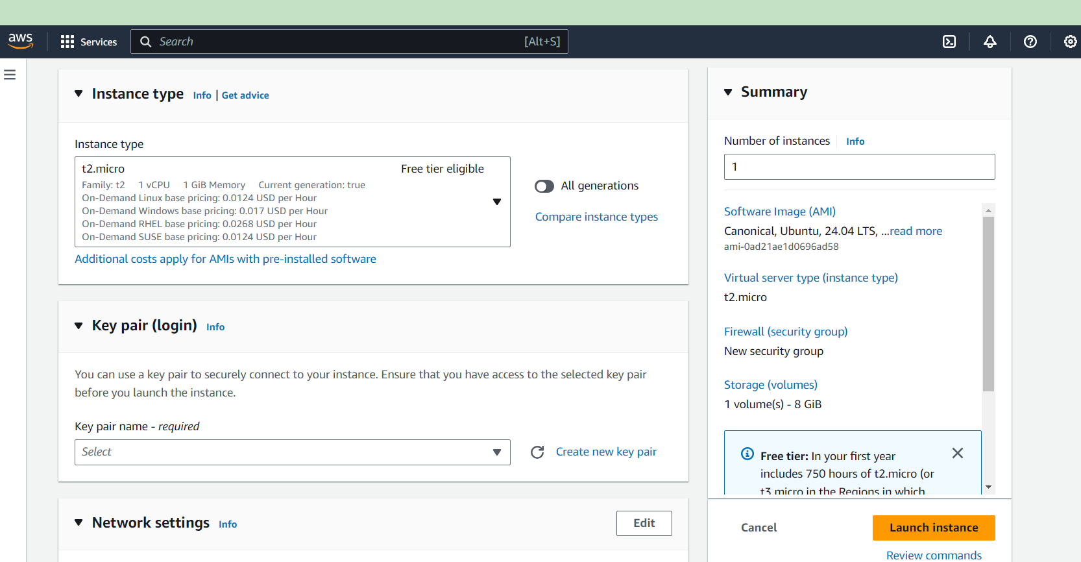

Instance types: We select our virtual CPUs and RAM/ memory associated. By default, the free tier eligible instance is selected. We select the latest “t2.micro” instance type.

To login to the particular instance, we need keypair. Select the “Create new key pair” option at right of the drop-down box.

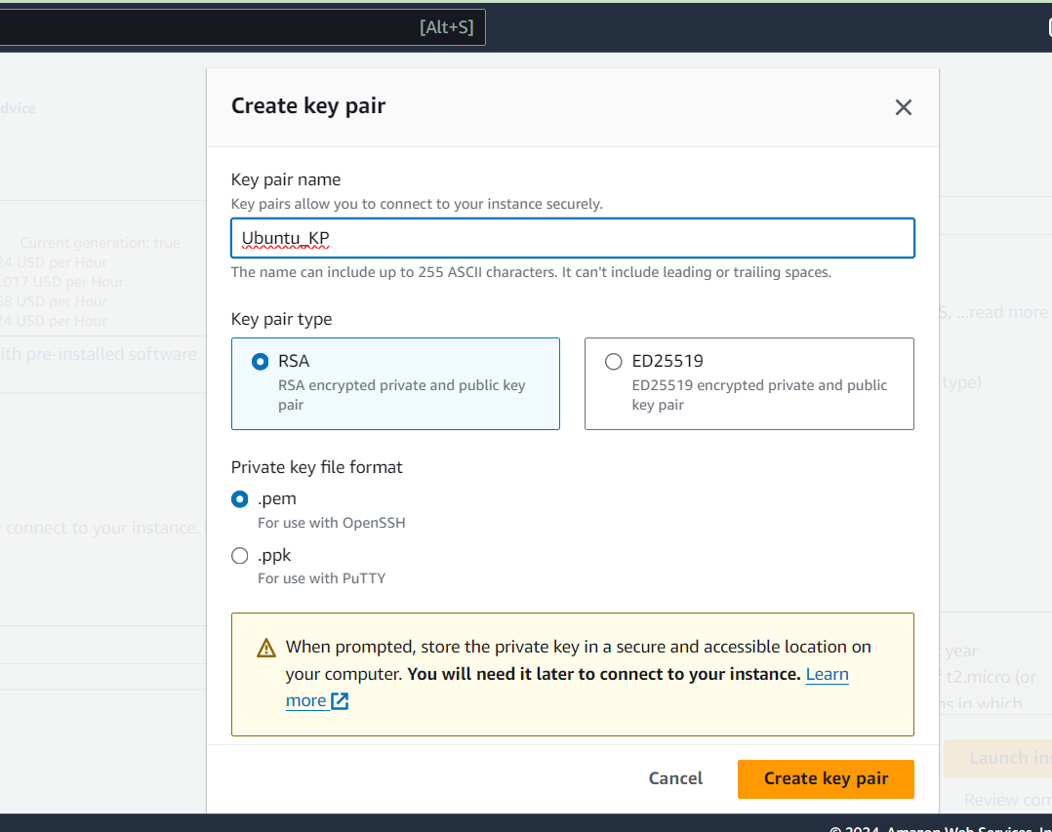

Assign name to key pair. Select “.pem” or “.ppk” key file format and create key pair. Accordingly, a file will be downloaded.

will be downloaded.



In “Network” settings, select “Create security group”. Select the 2 check boxes and then, at bottom right corner, select the “Launch” instance button to launch the instance.

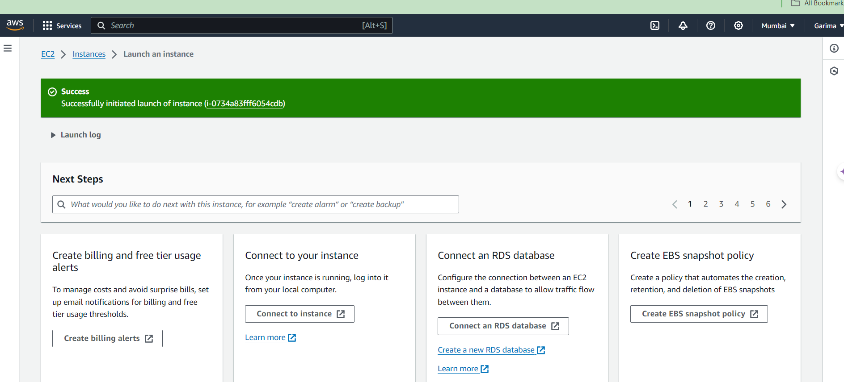

After successful launching of instance, we get the above message. Go to Instances from the above options to check for the instance that we have launched.

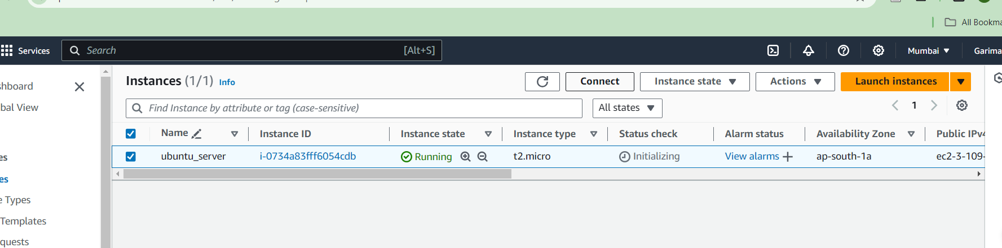

Here, we can see our instance in the Running state. To execute the Linux commands, we need to connect the instance to

So, we select the particular instance and at the top, select the “Connect” button.

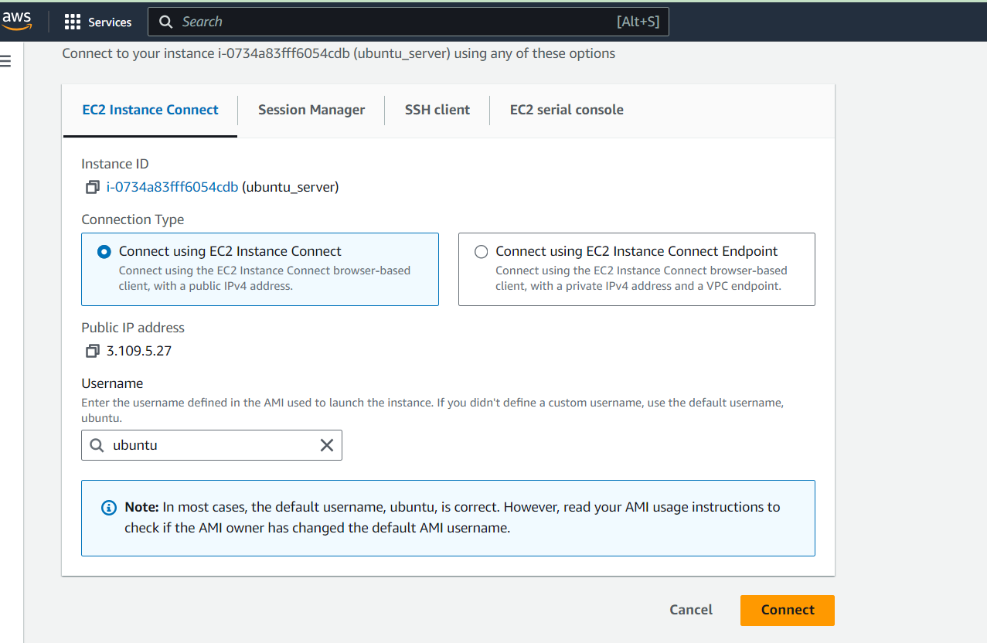

Without changing the selected options, we click connect button.

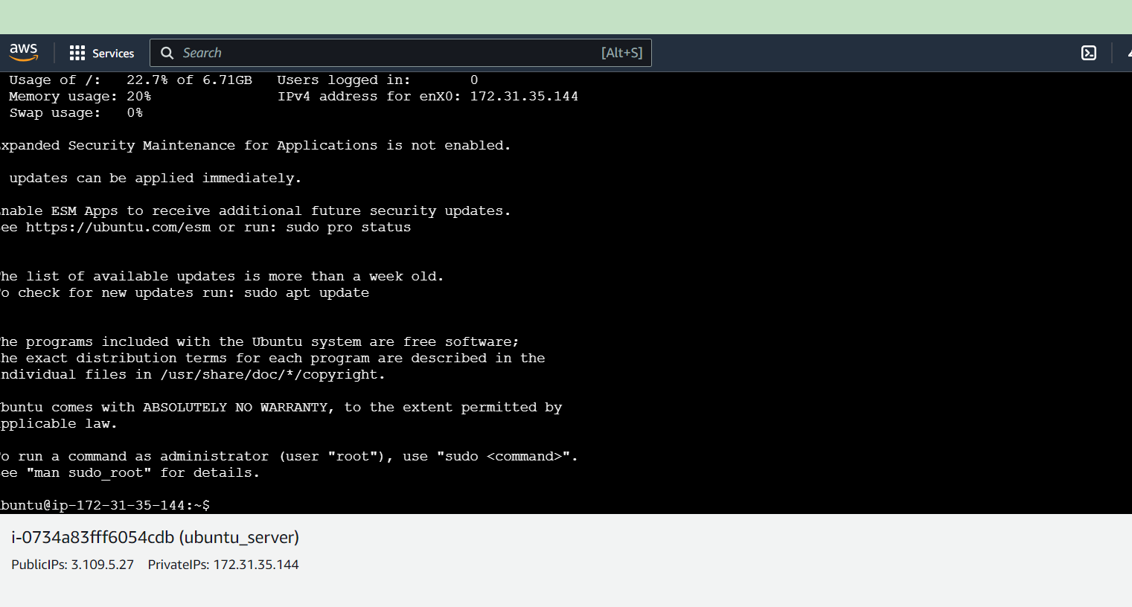

The instance is now connected to the virtual ubuntu machine.

The following 5 Linux commands have been executed on the machine.

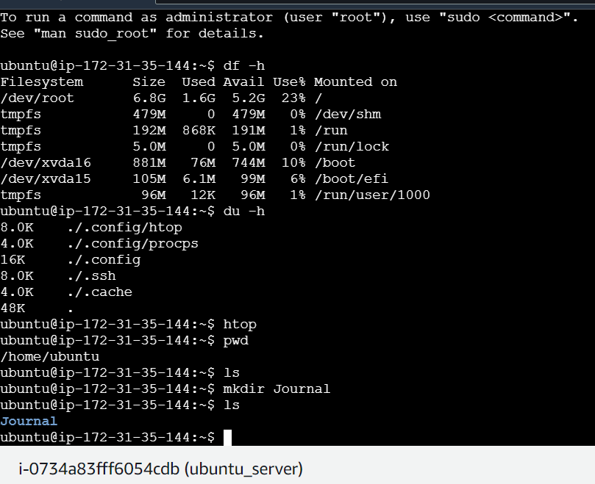

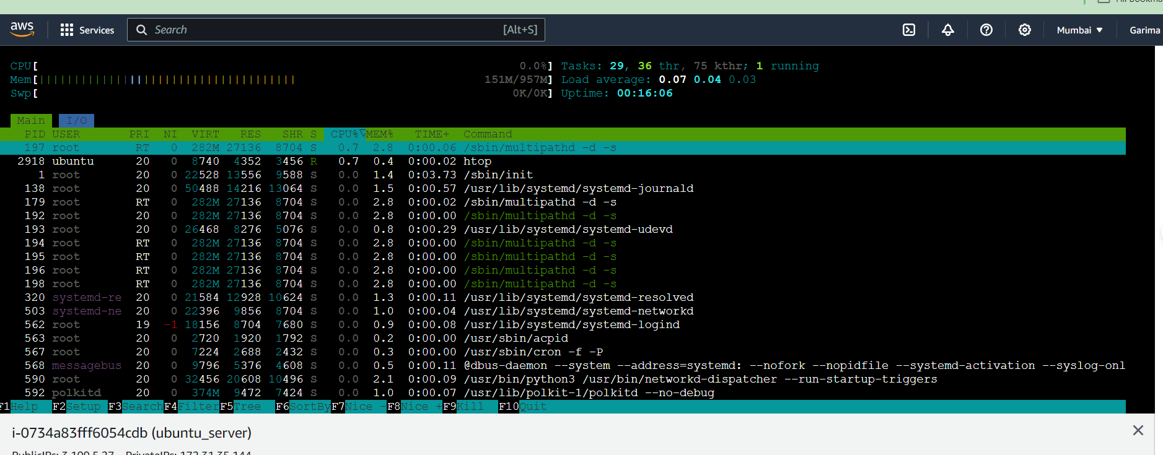

df -h: to see details of the machine. It says that total 6.8 GB of the root directory of which 23% of SSD is used

du -h: there is not much of the disk uses here

htop: to check machine details, CPU and machine utilizations. It tells that total there is 1 GB (957 MB) of RAM memory of which 151 MB memory is used up and almost 0% of CPU is being utilized

pwd: Allows to print current working directory on your terminal. Also, when creating scripts, it can be used to find the directory where the script has been saved

mkdir: allows to create directories from within the terminal. Here we created the Journal directory using this command.

ls: used to list files and directories in current working directory. Using command without any arguments gives an output with all files and directories in the directory. Initially, since there were no directories, when the command was given, we got no output. After a directory was created using the mkdir command, when the ls command was run, we got the output as the name of the directory created i.e. Journal.

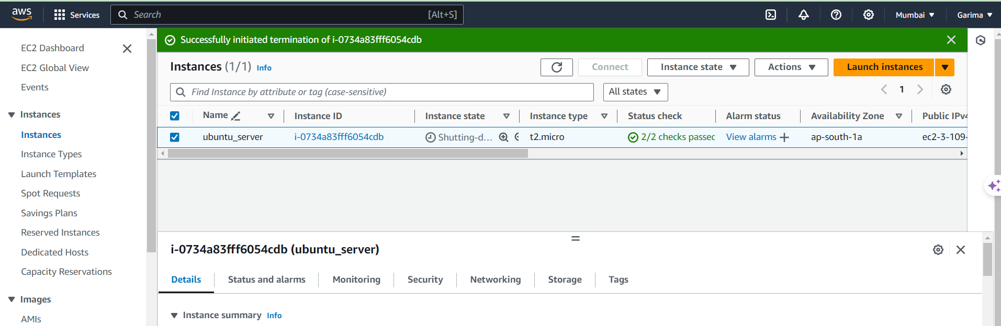

After executing the Linux commands, terminate the instance by going to the “Instance state” drop-down and select “Terminate instance” option. After terminating, we get the above page and the instance state in the list for that instance changes to “Shutting-Down” and then finally to “Terminated”.